Training
The classifier is a compact convolutional neural network (CompactCNN) consisting of three convolutional blocks with 32, 64, and 128 filters respectively, each followed by a ReLU activation and 2x2 max pooling. A global average pooling layer collapses the final feature maps into a single 128-length vector regardless of spatial size, which is passed to a fully connected classifier head (128 to 64 units with dropout of 0.3, then 64 to 6 output classes). This design keeps the parameter count low, which suits the relatively small, 6-class training set used in this project.
The processed dataset (6,823 training, 1,462 validation, and 1,463 test wafer maps across the six target classes) was used to train the model for 30 epochs with a batch size of 32, using the Adam optimizer at a learning rate of 0.001. Because the six classes are not evenly represented, the training loss used class weights computed from the training set's class frequencies, so that under-represented classes such as Donut and Scratch contribute proportionally more to the loss than the more common classes. Training was carried out locally on an AMD Radeon RX 6600 GPU using PyTorch DirectML.
Figure 1 shows the training and validation loss and accuracy across the 30 epochs. Both loss curves fall sharply over the first ten epochs before flattening out, and validation accuracy rises from 47.95% after the first epoch to a peak of 86.66%, reached at epoch 27 and matched again at epoch 28. From roughly epoch 22 onward, training accuracy continues to climb toward 90.83% by epoch 30 while validation accuracy plateaus and validation loss stops improving, a sign of mild overfitting in the later epochs. For this reason the training script saves the model checkpoint only when validation accuracy improves, rather than saving the final epoch's weights, so the checkpoint used for evaluation corresponds to the epoch 27/28 result rather than a possibly overfit later epoch.
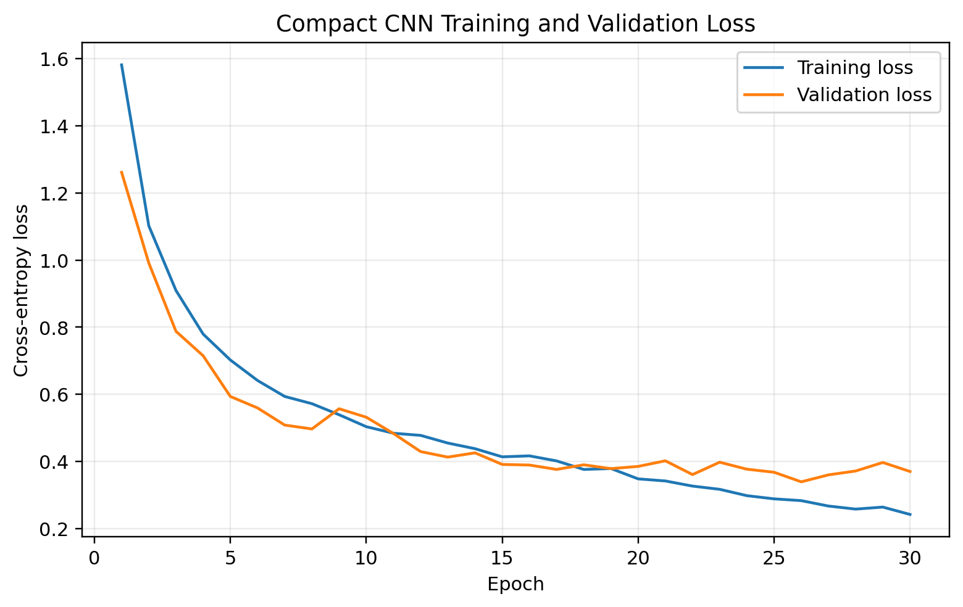 | 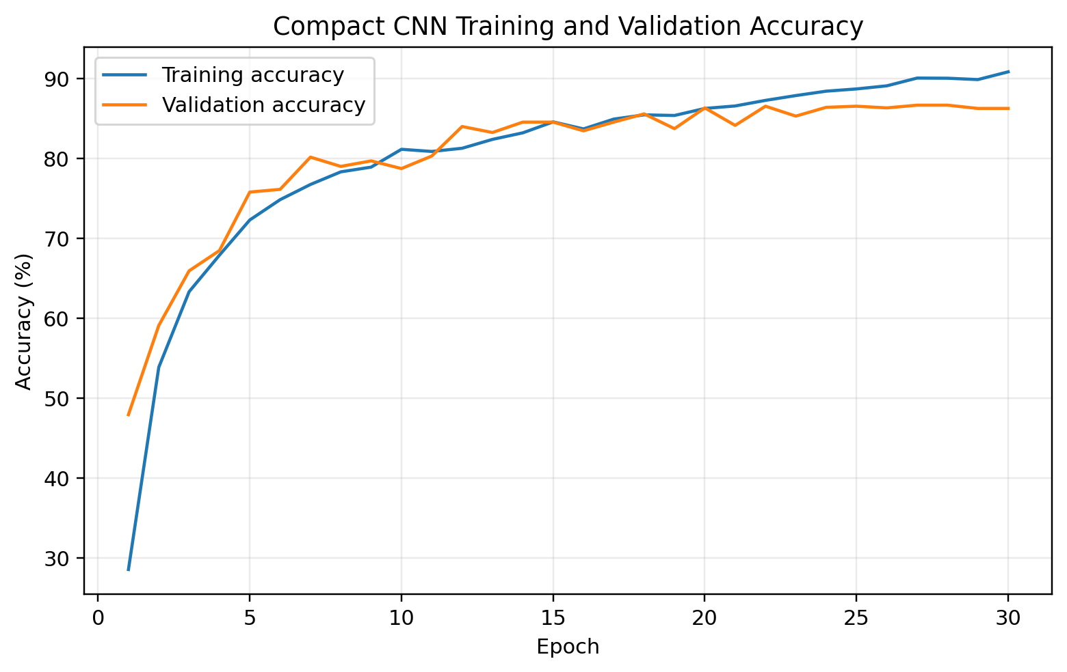
Figure 1. Training and validation loss (left) and accuracy (right) across 30 epochs.

Evaluation
The saved checkpoint was evaluated once on the held-out test set of 1,463 wafer maps, which the model had not seen during training or validation. It achieved an overall accuracy of 85.71%, a macro-averaged F1-score of 85.21%, and a weighted-averaged F1-score of 85.38%. Because accuracy alone can hide poor performance on minority classes, per-class precision, recall, and F1-score were also computed and are reported in Table 1.
Class | Precision (%) | Recall (%) | F1-score (%) | Support
Center | 90.10 | 94.00 | 92.01 | 300
Donut | 89.16 | 88.10 | 88.62 | 84
Edge-Loc | 84.47 | 87.00 | 85.71 | 300
Edge-Ring | 93.38 | 98.67 | 95.95 | 300
Loc | 84.30 | 62.67 | 71.89 | 300
Scratch | 70.18 | 85.47 | 77.08 | 179
Macro avg | 85.26 | 85.98 | 85.21 | 1463
Weighted avg | 85.94 | 85.71 | 85.38 | 1463
Table 1. Per-class precision, recall, F1-score, and support on the test set.
Performance is not uniform across classes. Edge-Ring is the strongest class, with a 95.95% F1-score and a recall of 98.67%, meaning the model correctly identifies almost every Edge-Ring wafer in the test set. Loc is the weakest class, with an F1-score of only 71.89% and a recall of just 62.67%. The confusion matrix in Figure 2 shows why: of the 300 true Loc wafers, 47 were misclassified as Scratch and a further 34 as Edge-Loc, compared to only 188 correctly identified as Loc. This is a reasonable failure mode rather than a random one, since Loc and Scratch defects are both localized, irregularly shaped clusters of failed dies without the strong, easily distinguishable global shape that classes like Edge-Ring (a ring around the whole wafer edge) or Center (a blob in the middle) have. Figure 3 summarizes the per-class F1-scores visually, making this gap between the strongest and weakest classes easy to see at a glance.
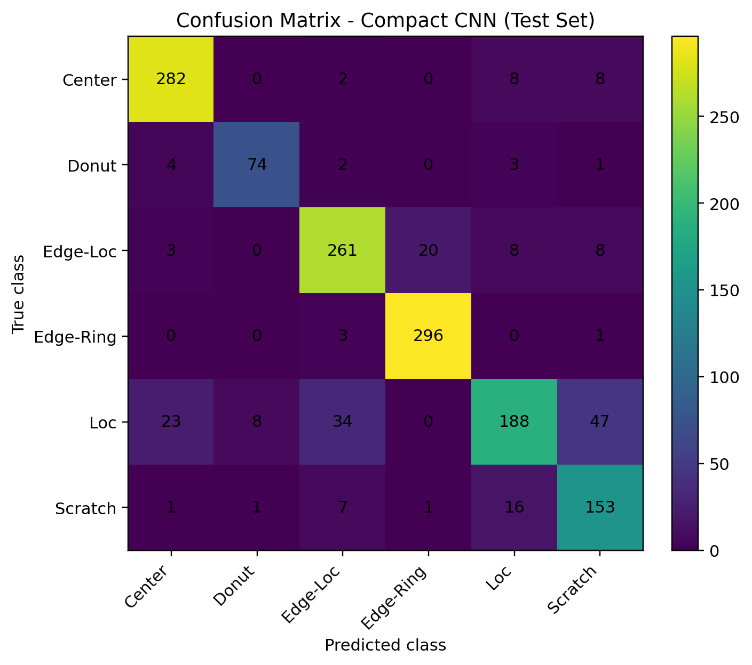 | 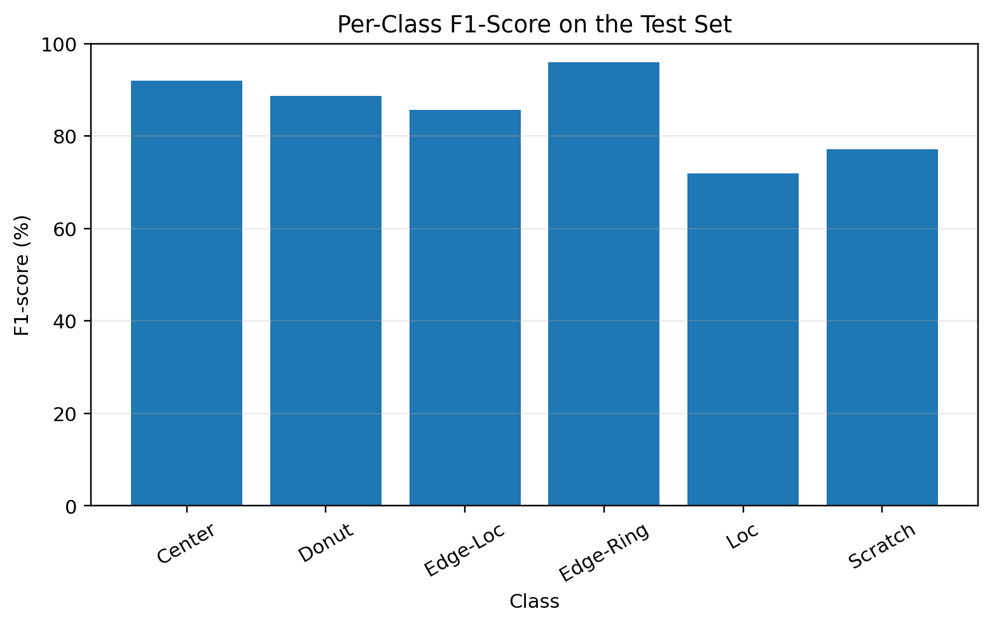
Figure 2 (left). Confusion matrix on the test set. Figure 3 (right). Per-class F1-score on the test set.

Prototype
To demonstrate the trained model working end to end, a lightweight web interface was built using Streamlit. This is a prototype for demonstration purposes rather than the project's core deliverable, which is the trained classifier itself. The WM-811K dataset provides only a defect-pattern label per wafer map and no bounding-box or pixel-level defect location annotations, so the prototype demonstrates whole-wafer-map classification rather than defect localization, consistent with the project's original scope.
The app loads the trained CompactCNN checkpoint and the held-out test set. The user can step through test wafer maps one at a time, or jump to a random one, using the on-screen navigation controls. For the selected wafer map, the app displays the wafer map image, the model's predicted defect class with its confidence, the true label for comparison, and a bar chart of the predicted probability across all six classes.
Figure 4 shows the prototype correctly classifying an Edge-Ring wafer with 100% confidence, reflecting that class's strong test-set performance. Figure 5 shows a correctly classified Loc wafer, also with high confidence, where the defect pattern happens to be unambiguous. Figure 6 shows a case where the true label is Scratch and the model's top prediction is also Scratch, but only at 52.6% confidence, with a substantial 32% of the probability mass assigned to Loc. This example visually illustrates the same Loc/Scratch confusion identified in the confusion matrix in the Evaluation section, and demonstrates that the model's confidence output is meaningfully informative rather than arbitrary, since it is visibly less certain on exactly the pair of classes it struggles with most.
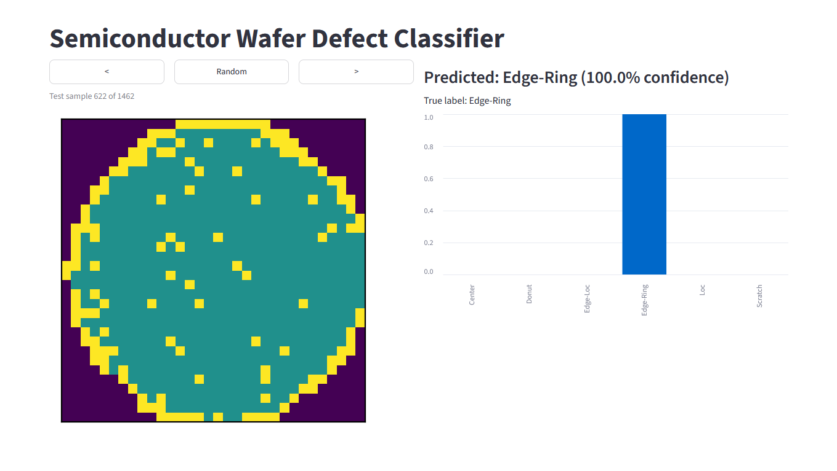
Figure 4. Prototype correctly classifying an Edge-Ring wafer with 100% confidence.
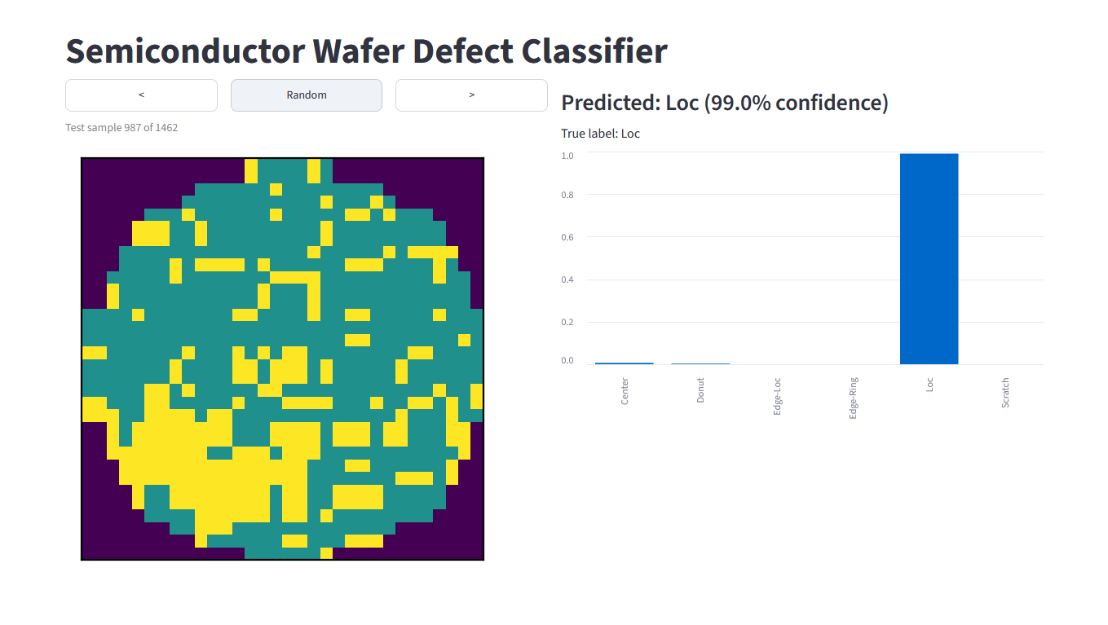
Figure 5. Prototype correctly classifying a Loc wafer with 99.0% confidence.
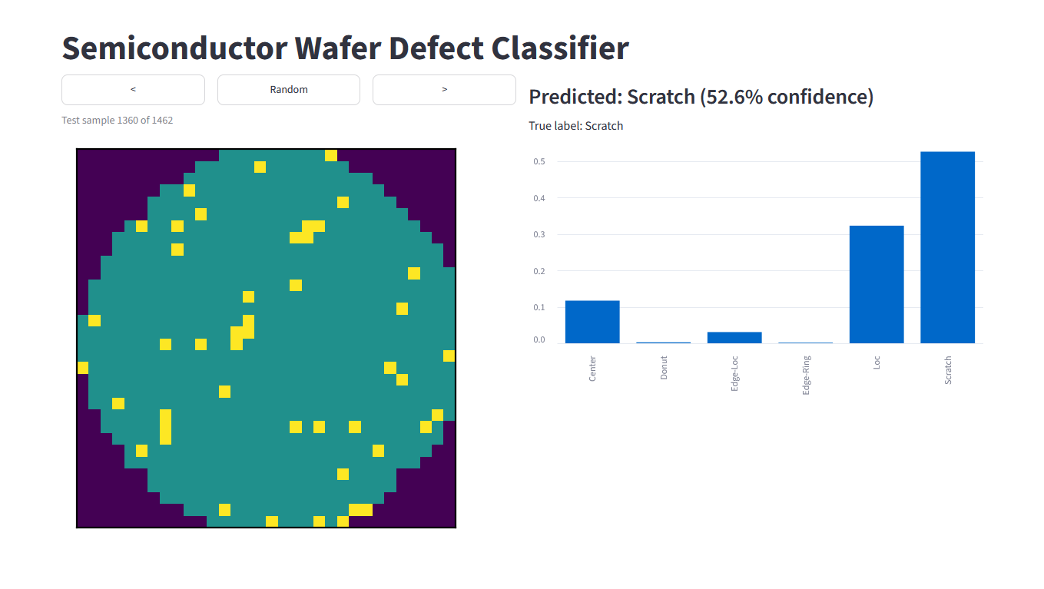
Figure 6. A true Scratch wafer predicted correctly but with only 52.6% confidence, with 32% probability assigned to Loc, illustrating the model's known Loc/Scratch confusion.
The prototype is run locally with the command "streamlit run src/app.py" from the project root, with the project's Python environment activated, and opens automatically in the browser.

